实 验 报 告
《 慕测平台进行白盒测试 》实验 二
专业 计算机 班级 计算机142 实验日期 2017 年 4月 12 日
学号 2014211436 姓名 蔡梦璋 同组学生姓名
课程名称 | 软件测试技术
实验名称 | 慕测平台进行白盒测试
实验地点与  实验环境 | 实验环境（硬/软件要求）：  Eclipse  实验地点：807
实验主要内容与步骤 | 测试脚本  ：import static org.junit.Assert.*;  import org.junit.Test;  public class SortingTest {  @Test  public void testInsertionSort() {  Sorting ss =new Sorting();  int a[]=new int[]{320,11,224,272,72,170,322,173,35,113,250,309,260,227,379,88,56,387,258,16,321,49,314,354,83,54,171,225,3,322,163,355,300,228,120,328,308,250,156,216};  int b[]=new int[]{3,11,16,35,49,54,56,72,83,88,113,120,156,163,170,171,173,216,224,225,227,228,250,250,258,260,272,300,308,309,314,320,321,322,322,328,354,355,379,387};  ss.insertionSort(a);  assertArrayEquals(b, a);  }  @Test  public void testIsSorted() {  Sorting ss =new Sorting();  int a[]=new int[]{320,11,224,272,72,170,322,173,35,113,250,309,260,227,379,88,56,387,258,16,321,49,314,354,83,54,171,225,3,322,163,355,300,228,120,328,308,250,156,216};  int b[]=new int[]{3,11,16,35,49,54,56,72,83,88,113,120,156,163,170,171,173,216,224,225,227,228,250,250,258,260,272,300,308,309,314,320,321,322,322,328,354,355,379,387};  assertEquals(true, ss.isSorted(b));  assertEquals(false, ss.isSorted(a));  }  @Test  public void testQuicksort() {  int a[]=new int[]{184,450,152,448,41,410,284,78,122,146,192,320,449,397,198,  227,83,179,165,287,495,70,311,251,41,74,481,  17,117,331,76,387,348,495,14,201,430,112,263,459,429,35,53,  146,376,65,30,90,52,496};  int b[]=new int[]{14,17,30,35,41,41,52,53,65,70,74,76,78,83,90,  112,117,122,146,146,152,165,179,  184,192,198,201,227,251,263,284,287,311,320,331,348,  376,387,397,410,429,430,448,449,450,459,481,495,495,496};  Sorting.quicksort(a);  assertArrayEquals(b, a);  }  @Test  public void testSwapReferences() {  Integer a[]=new Integer[]{184,450,152,448,41,410,284,78,122,146,192,320,449,397,198,  227,83,179,165,287,495,70,311,251,41,74,481,  17,117,331,76,387,348,495,14,201,430,112,263,459,429,35,53,  146,376,65,30,90,52,496};  Integer b[]=new Integer[]{184,152,450,448,41,410,284,78,122,146,192,320,449,397,198,  227,83,179,165,287,495,70,311,251,41,74,481,  17,117,331,76,387,348,495,14,201,430,112,263,459,429,35,53,  146,376,65,30,90,52,496};  Sorting.swapReferences(a, 1, 2);  assertArrayEquals(b, a);  }  @Test  public void testSwap() {  int a[]=new int[]{184,450,152,448,41,410,284,78,122,146,192,320,449,397,198,  227,83,179,165,287,495,70,311,251,41,74,481,  17,117,331,76,387,348,495,14,201,430,112,263,459,429,35,53,  146,376,65,30,90,52,496};  int b[]=new int[]{184,152,450,448,41,410,284,78,122,146,192,320,449,397,198,  227,83,179,165,287,495,70,311,251,41,74,481,  17,117,331,76,387,348,495,14,201,430,112,263,459,429,35,53,  146,376,65,30,90,52,496};  Sorting.swap(a, 1, 2);  assertArrayEquals(b, a);  }  }  测试覆盖率：  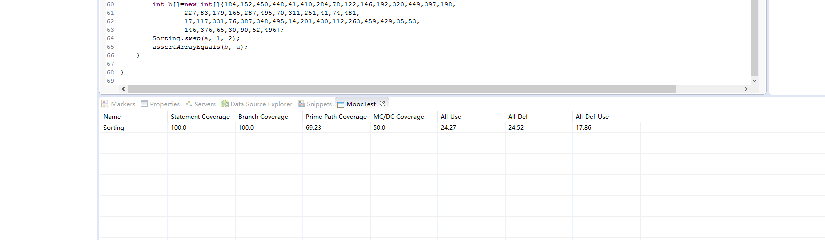
实验结果(结论)
或存在的问题
得分

注：学生做每个实验都必须写实验报告。实验报告可以是纸质的，也可以是电子形式的。实验报告（如是电子形式的必须刻成光盘）在学期结束时交给教务科存档。
实验指导教师签名 年 月 日

